



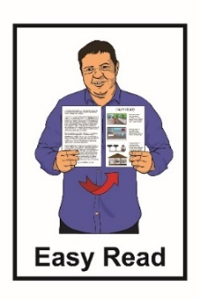
Looking after yourself
if you are sick
with COVID-19


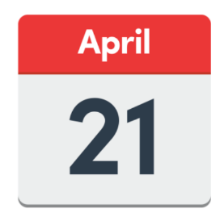

Published:
21 April 2022
What you will find in here

Page number:

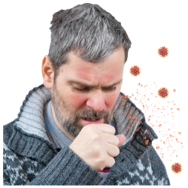
What is this document about?............3


COVID-19 symptoms……………..…..4

What to do if you have a sore

throat..................................................7

What to do if you have a runny
nose……………………...……………..9


What to do if you have a cough…….12
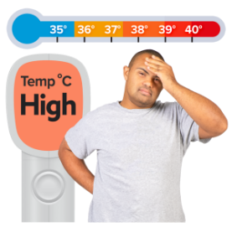

What to do if you have a fever….….13
Page number:
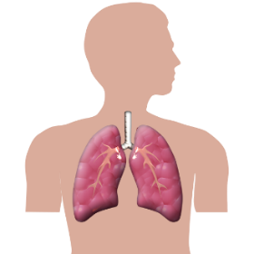

What to do if you find it hard to breathe………………………………..17


What to do if you have an upset stomach……………………………….18

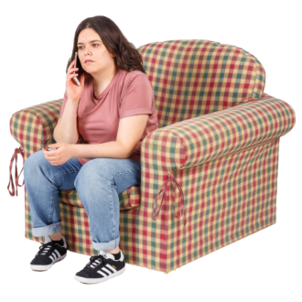
Getting medical care……………..….21

Where to find more information….…23

What is this document about?


This document tells you how to look after yourself if you get sick with
COVID-19.


COVID-19 is a type of virus that can make people sick.

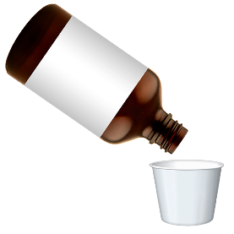
There is no cure for COVID-19 yet.

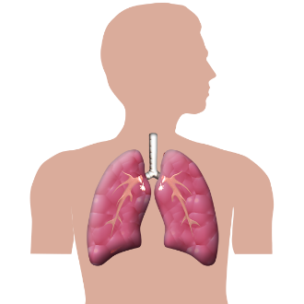
COVID-19 can affect your:

- lungs

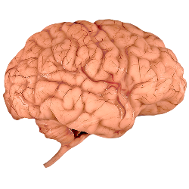
- airways

- other organs / parts of your body.

COVID-19 symptoms


COVID-19 symptoms can be:

- a sore throat
- sneezing / having a runny nose

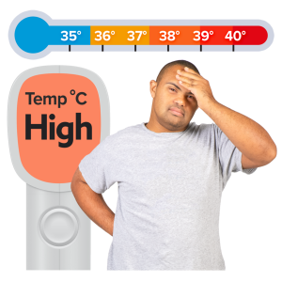
- a new cough / a cough that gets worse

- a high temperature / fever of at least 38°C on a thermometer –feeling very hot
- finding it hard to breathe

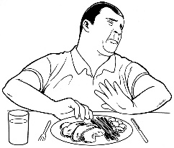
- not being able to smell things for a little while

- not being able to taste things for a little while.
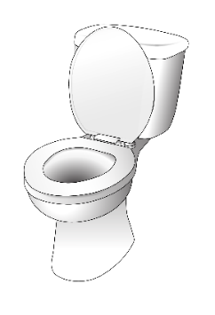
Some other COVID-19 symptoms can be:

- diarrhoea / runny poo
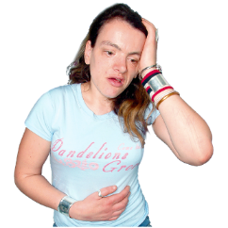
- having a headache
- muscle pain or body aches
- nausea / feeling sick

- vomiting / being sick
- malaise – a general feeling of being unwell
- chest pains

- stomach pains

- pains in your bones / your joints hurt

- confusion / feeling frustrated.
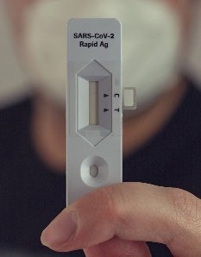
It is important to remember that you need to stay home if you have:

- done a test that says you have COVID-19

- any COVID-19 symptoms.

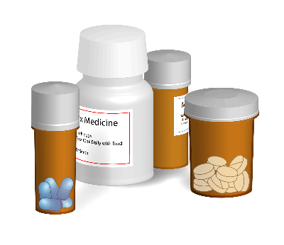
If you need any medicine or food from the pharmacy or supermarket you will need to ask someone else to get it for you.
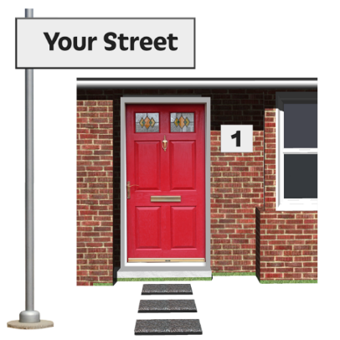


This person will need to leave the medicine or food at your front door.

What to do if you have a sore throat

If you have a sore throat you can try some of these ideas to make it feel better.

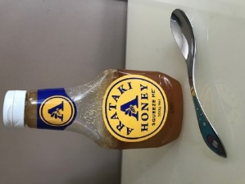
You can try sucking:

- a teaspoon of honey

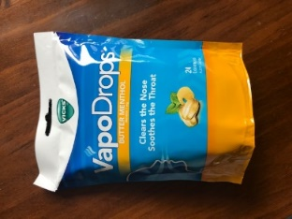
- sugar-free lollies

- lozenges.

You can use a throat spray.
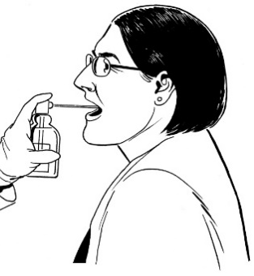

A throat spray is something you can buy from the pharmacy to help your throat feel better.

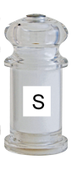
Another way to make a sore throat feel better is to gargle with:

- salt water


- warm water.

Gargle means that you swish the water around your mouth.
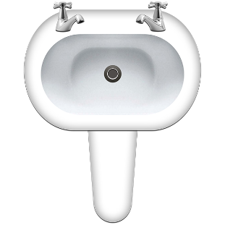

After the water has been all around your mouth spit it out in the sink.


Do not swallow the water.

What to do if you have a runny nose

If you have a runny nose there are a few ways to make it feel better like using:

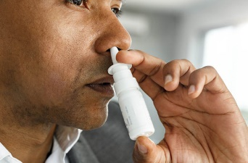
- saline nose drops

- nose spray.

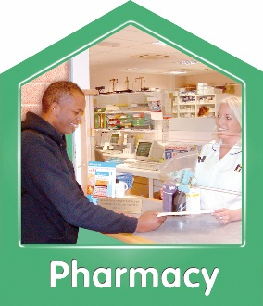
If you have medicine from the pharmacy to unblock your nose check how many days you can use it for.
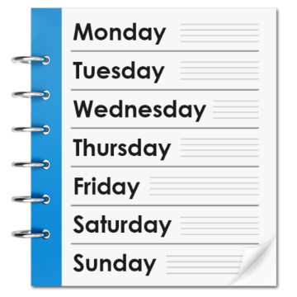

Some medicine to unblock your nose should only be used for 7 days.

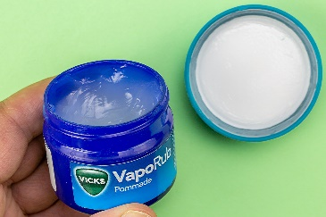
Some people like to use vapour rubs that contain essential oils like:

- menthol
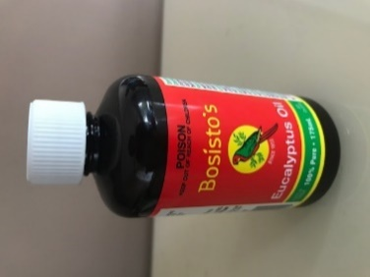
- camphor

- eucalyptus.

Vapour rubs give off a strong smell that help your airways to open up.

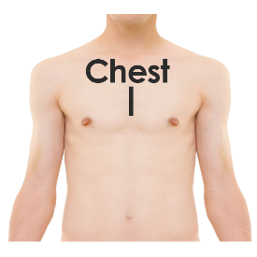
Gently rub the vapour rub on:

- the outside of your throat under your chin

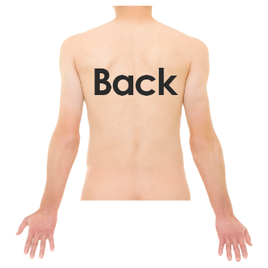
- your chest

- your back.


After you have rubbed in the vapour rub leave your clothes loose so you can breathe in the vapours.

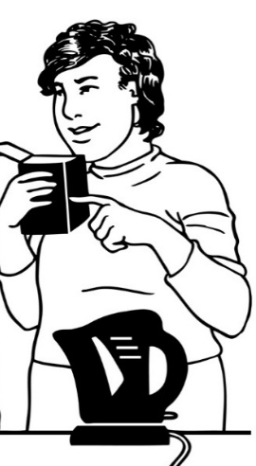
Some people like to breathe in vapour steam.

Vapour steam is when you add vapour rub to hot water then breathe in the steam.

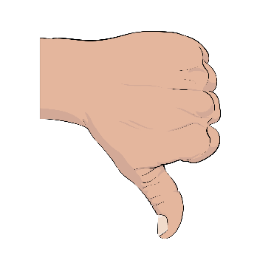
Scientists say this can be dangerous because you can burn yourself on the hot water.

What to do if you have a cough

Coughs can usually be treated with things you have at home.

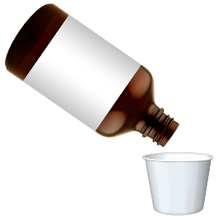
You might not need special cough medicine.


You can try:

- sucking a teaspoon of honey

- drinking a hot drink.

What to do if you have a fever

A fever is a high temperature of over 38 degrees C.

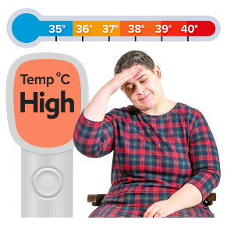
If you have a fever you will feel very hot.


A fever is a way that your body fights against the COVID-19 virus.

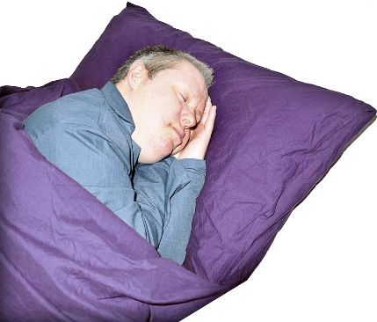
Here are ways to feel better if you have a fever:

- get lots of rest

- drink lots of water.

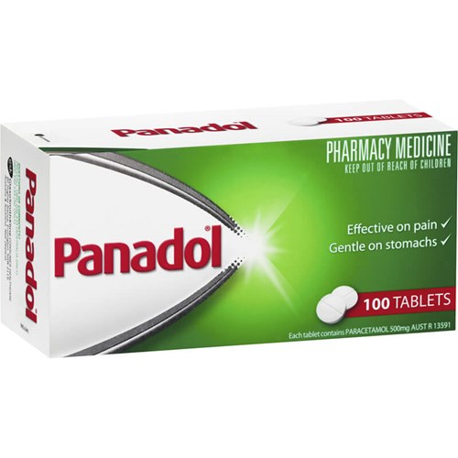
If you have a fever you might also want to take tablets to make you feel more comfortable like:
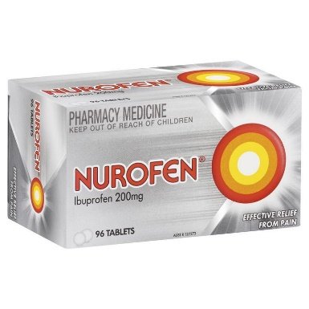
- paracetamol like Panadol

- ibuprofen like Nurofen.

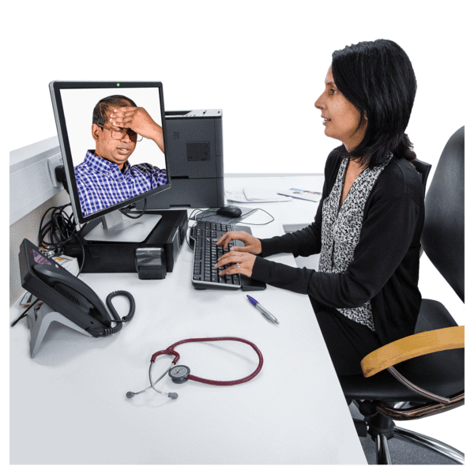
You can phone your doctor or the pharmacist to check that it is okay for you to take these tablets.

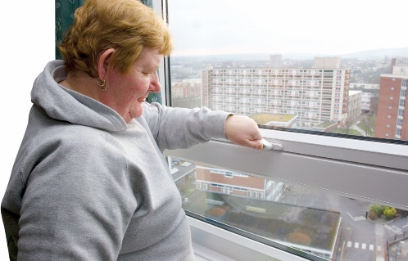
Some other ways to feel better if you have a fever are:

- open a window for fresh air

- wear light clothes like t-shirts – not warm clothes like jerseys.

Some other ways to feel better if you have a fever are:

- use light linen on your bed like a sheet


- make sure your room is not:

- too hot

- too cold.

- use a cool cloth to wash your:
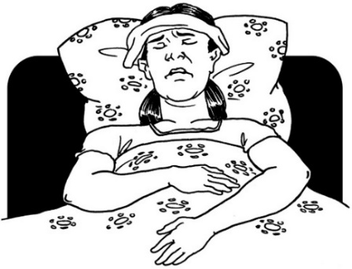
- face

- hands

- neck.

- change your bed linen if it gets wet with sweat.

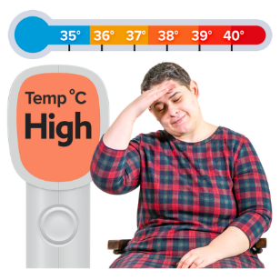
If you are hot with a fever try not to use things that will make you warmer like:

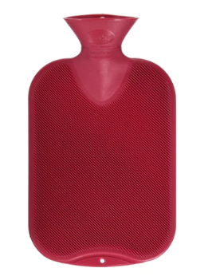
- hot water bottles

- electric blankets.

What to do if you find it hard to breathe

COVID-19 can cause problems with breathing.

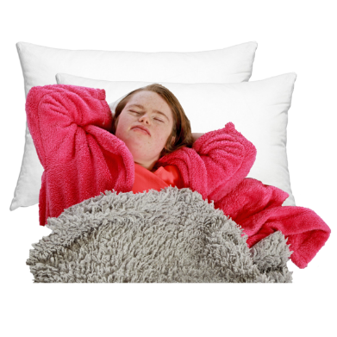
Lying on your back can make it harder to breathe.

Moving around can help to move the air through your lungs.


Try these different positions:

- lying on your tummy
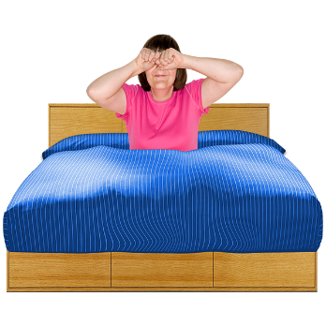
- lying on 1 side for a while then changing over to the other side

- sitting upright.

What to do if you have an upset stomach

Some people with COVID-19 can have:

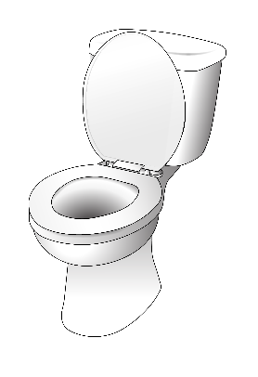
- diarrhoea / runny poo
- nausea / feeling sick

- vomiting / being sick.

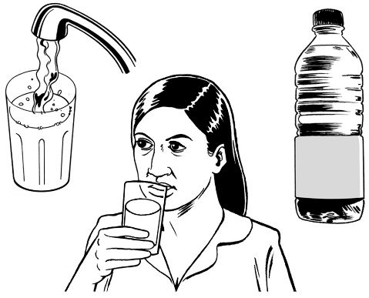
Most people should feel better in a few days.

The most important thing is to keep enough water / fluid in your body.

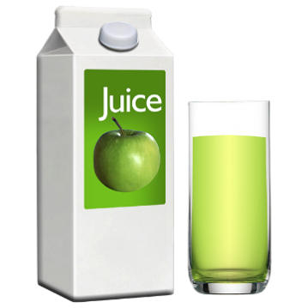
Drinking apple juice with some water in it can help you feel better.


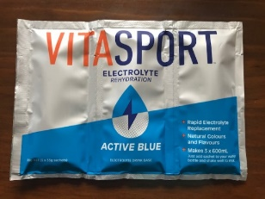
You can also drink electrolytes which are a powder that you put into water.


You should try not to drink sugar because it can make your diarrhoea / runny poos worse.

Try not to choose drinks with lots of sugar like:

- fizzy drinks

- undiluted fruit juices / fruit juice without water added
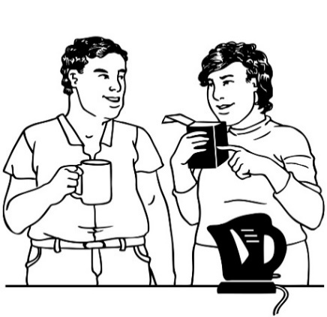
- tea

- coffee

- sports drinks.

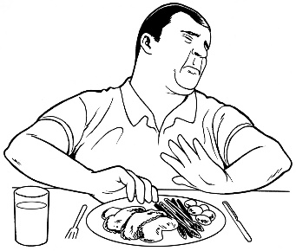
If you feel sick you should just eat when you feel able to.


There is no special food you have to eat to make you better.

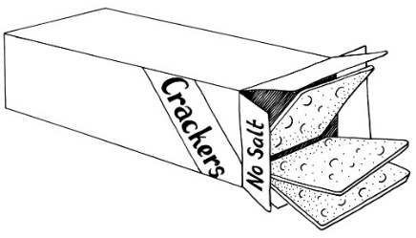
Some people find it easier to eat bland foods like:

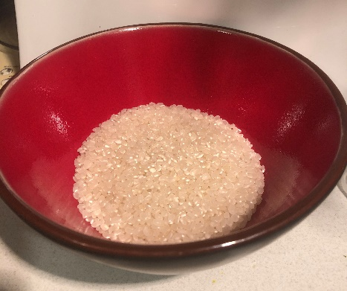
- crackers

- rice

- dry toast.

If you feel sick for more than a few days talk to your doctor as they might want to give you medicine to make you feel better.

Getting medical care

If your symptoms get worse you should call:

- your doctor

- Healthline on 0800 358 5453.
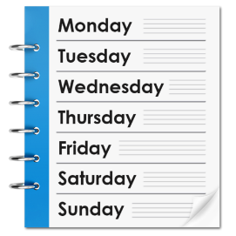

The Healthline phone line is open:



- everyday
- all day and all night.


It does not cost any money to call the Healthline phone number.


If you find it hard to use the phone the New Zealand Relay service is for people who:

- are deaf / hard of hearing

- are deafblind
- find it hard to talk.


You can find more about the New Zealand Relay service at this website:

www.nzrelay.co.nz/index

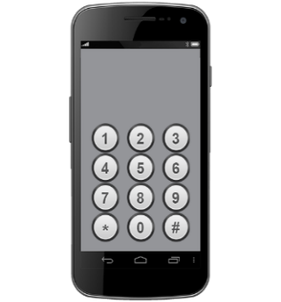
111
If any of your symptoms get really bad you should call 111 for medical help.

Where to find more information


The COVID-19 government website is:

www.covid19.govt.nz

You can use this website to find out more information about:

- looking after yourself if you have COVID-19

- where to get support if you need it.

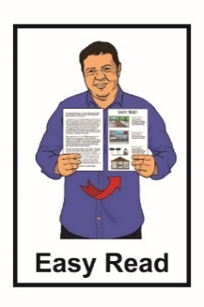
More information about COVID-19 is available in Easy Read on the
COVID-19 website:

www.covid19.govt.nz/easy-read/


This information has been written by the team at Unite against COVID-19.
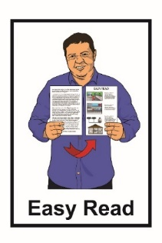
It has been translated into Easy Read by the Make It Easy service of People First New Zealand Inc. Ngā Tāngata Tuatahi.


The ideas in this document are not the ideas of People First New Zealand Inc. Ngā Tāngata Tuatahi.


Make It Easy uses images from:

- Changepeople.org


- Photosymbols.com


- Sam Corliss

- Huriana Kopeke-Te Aho.


All images used in this Easy Read document are subject to copyright rules and cannot be used without permission

